**The Ark Documentation.**

**How to use the subject uploader to update an existing subject.**

Instruction Path a (with perfect data and no validation)

Log in and select our study.

Once we have chosen our study we will see the following (Study) functions, the last of which is Subject Upload. Click that function.

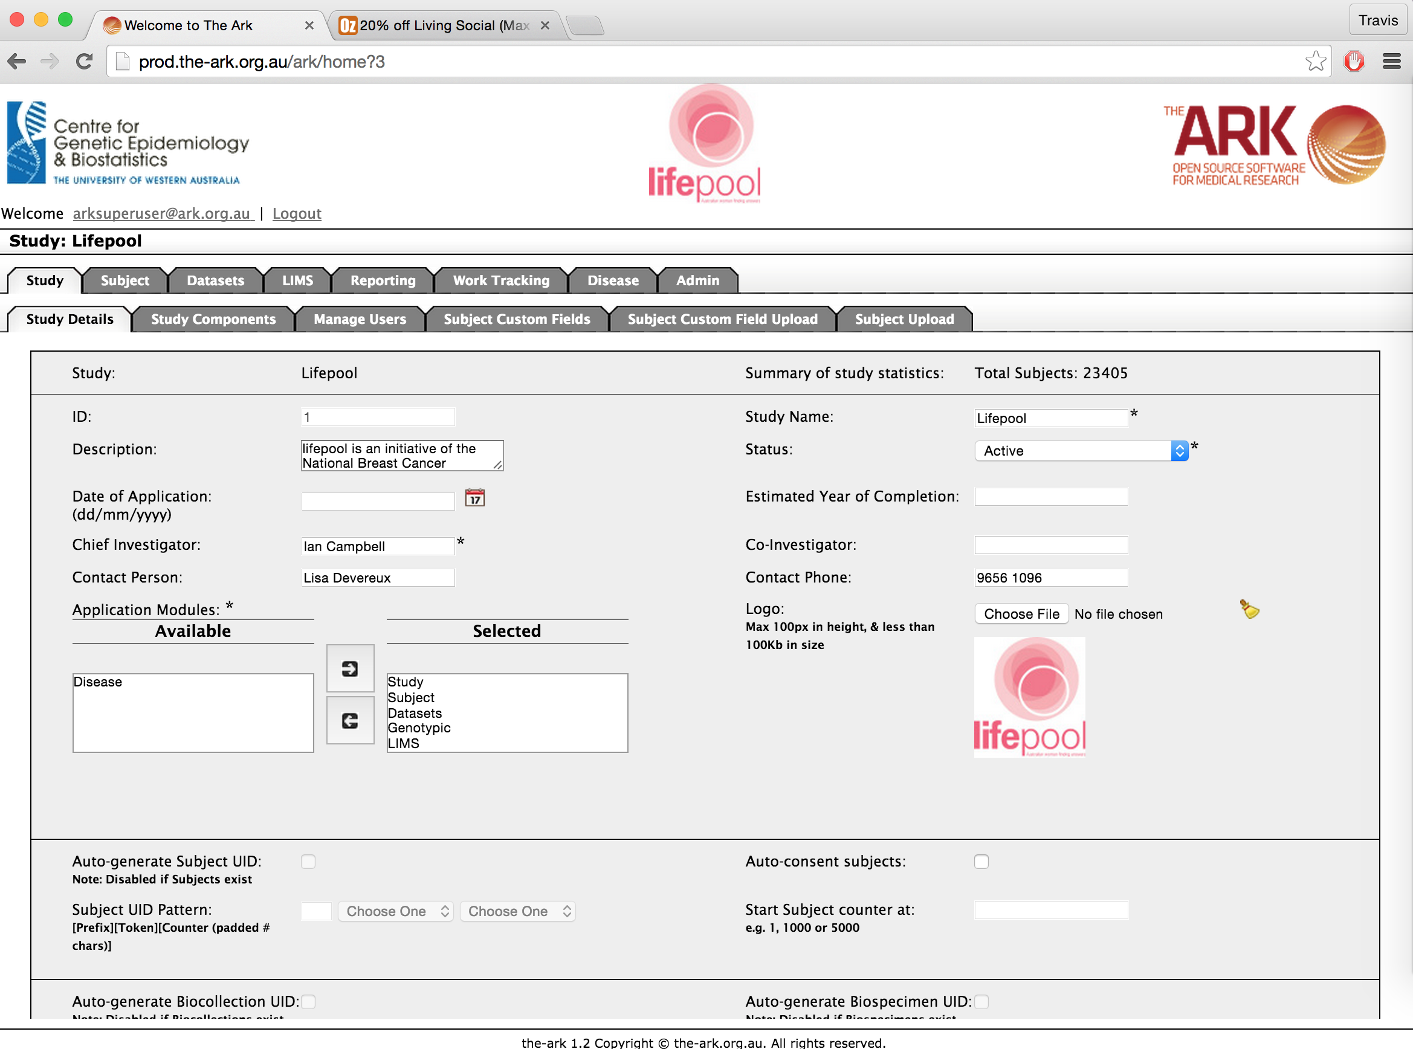

The following page will appear. You will see the following sections from top to bottom;

1. The files upload section. This is where you can begin the steps to upload subjects.
2. The Labels and Template download section. This will be described further below.
3. The Result list section. This section lists all previous uploads.

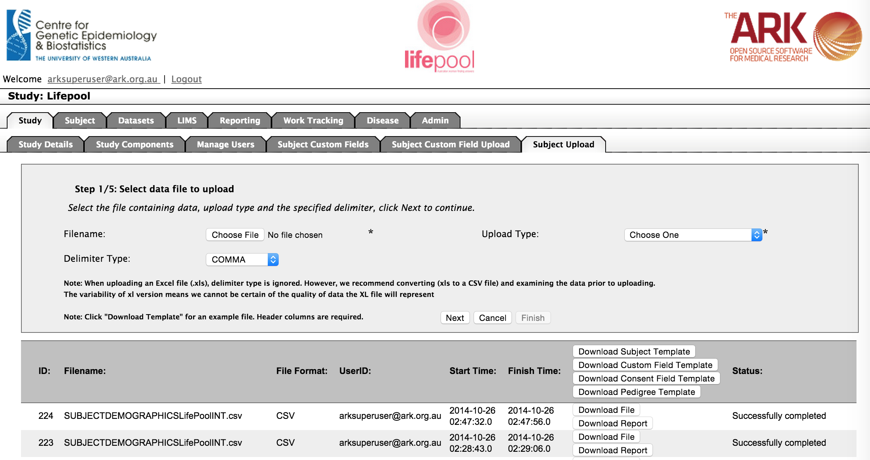

🡨1

🡨2

🡨3

The next step is to upload your data. You have two choices for your starting point;

1. You can select Download Subject Template if you are unsure which fields to include. The template lists which fields are mandatory, what type/format of data is expected and valid values for fields that are limited in that way (see below).



Once you have added your data to the template remove rows 2-6, so that your data now begins on row 2. Also remove column A, so that SUBJECTUID is the first column.

1. Alternatively, you can access an example from the usefulTools/csvTemplatesForUploaders directory of our code repository. If you have not been given a local version of our repository you can access it from

<https://code.google.com/p/ark-informatics/source/browse/#svn%2FARK%2Ftrunk%2FusefulTools%2FcsvDataForUploaders>

For the example below I utilized the SubjectUploadFromWhite.csv template file.

1. You can use your previous upload document which inserted the data. THIS IS NOT NECESSARILY THE BEST IDEA. YOU RISK OVERWRITING DATA SOMEONE CHANGED WITHIN THE ARK.

**All updates will be keyed on your use of the Subject UID. We don’t try to guess from names or any other demographic models. We use ONLY Subject UID! If you want a row updated be certain that you have the Subject UID correct!**

**IMPORTANT NOTE;**

Any time you overwrite/update from an excel document you risk overwriting data which may have changed since you last received that data. This is a bad process. Typically once you choose a repository such as The Ark, you are best to keep your data and modify it only in there. If you DO choose to update, minimize which columns you overwrite/update only to those you intend to overwrite. Don’t make any assumptions that data should not have changed!!!

Once you have taken the steps listed above to ensure you have the fields you wish to upload, save the file, then you simply;

1. Select the filename of that file in the “The files upload section“.
2. Select the “Subject Demographic Data” upload type
3. Leave the delimiter type as CSV (even if using an excel spreadsheet).
4. Click the Next button once.

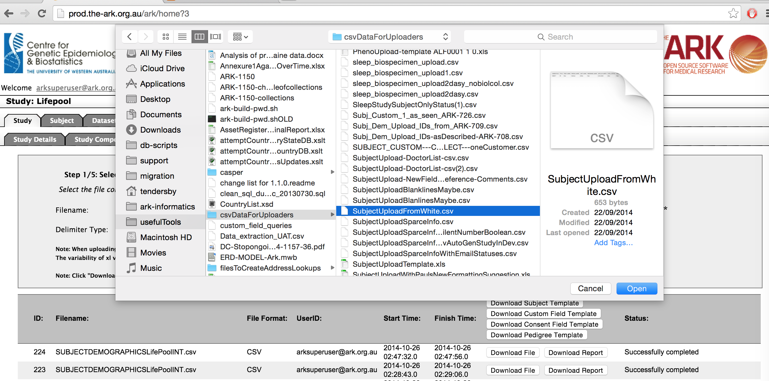

This will take you to the step 2. This page will let you know if the file structure is correct for the upload type. For example, if I misnamed the address columns (ADDRESS_LINE_1 and ADDRESS_LINE_2 instead of “STREET_ADDRESS and BUILDING_NAME” as the template and uploader expected expected) I would get the following type of error message;

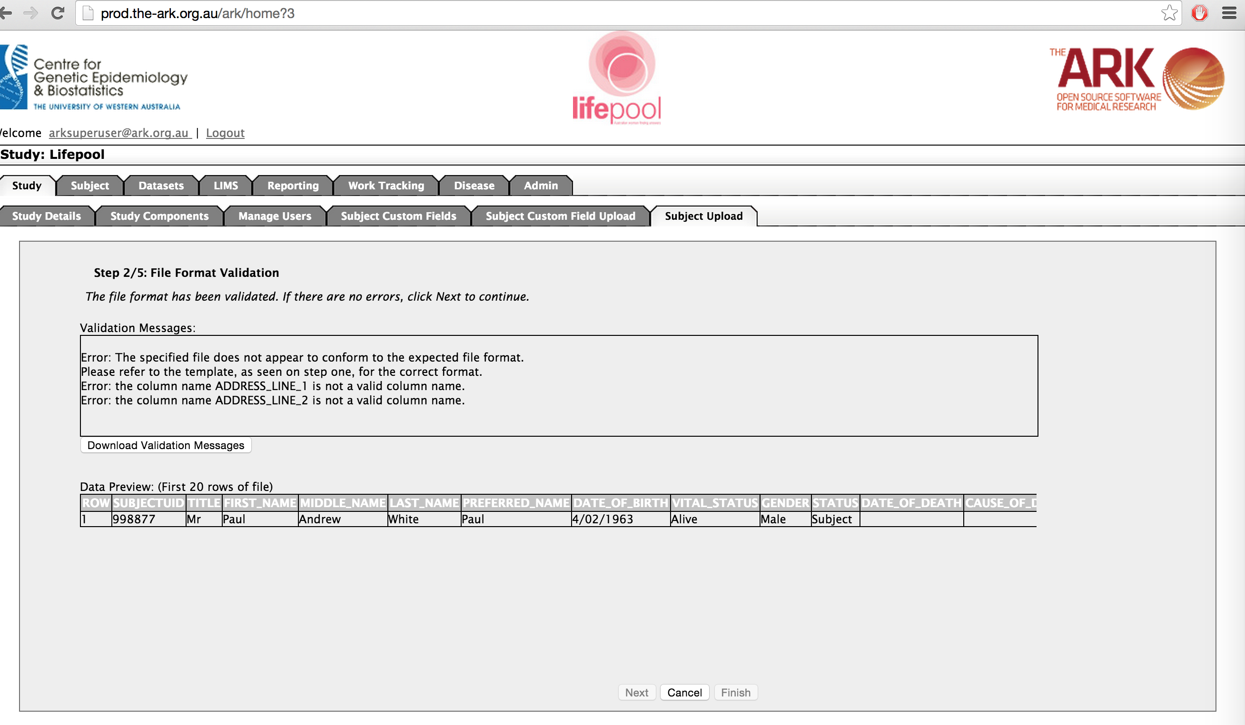

We can look back at the template and see that this is the expected naming, and correct our mistake.

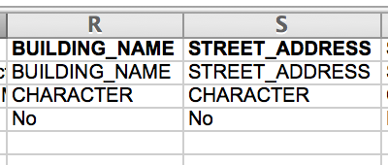

We click cancel at the bottom of the page and start the upload again

So now that I have corrected the headers on my file, I repeat step one and see if there is any more mistakes

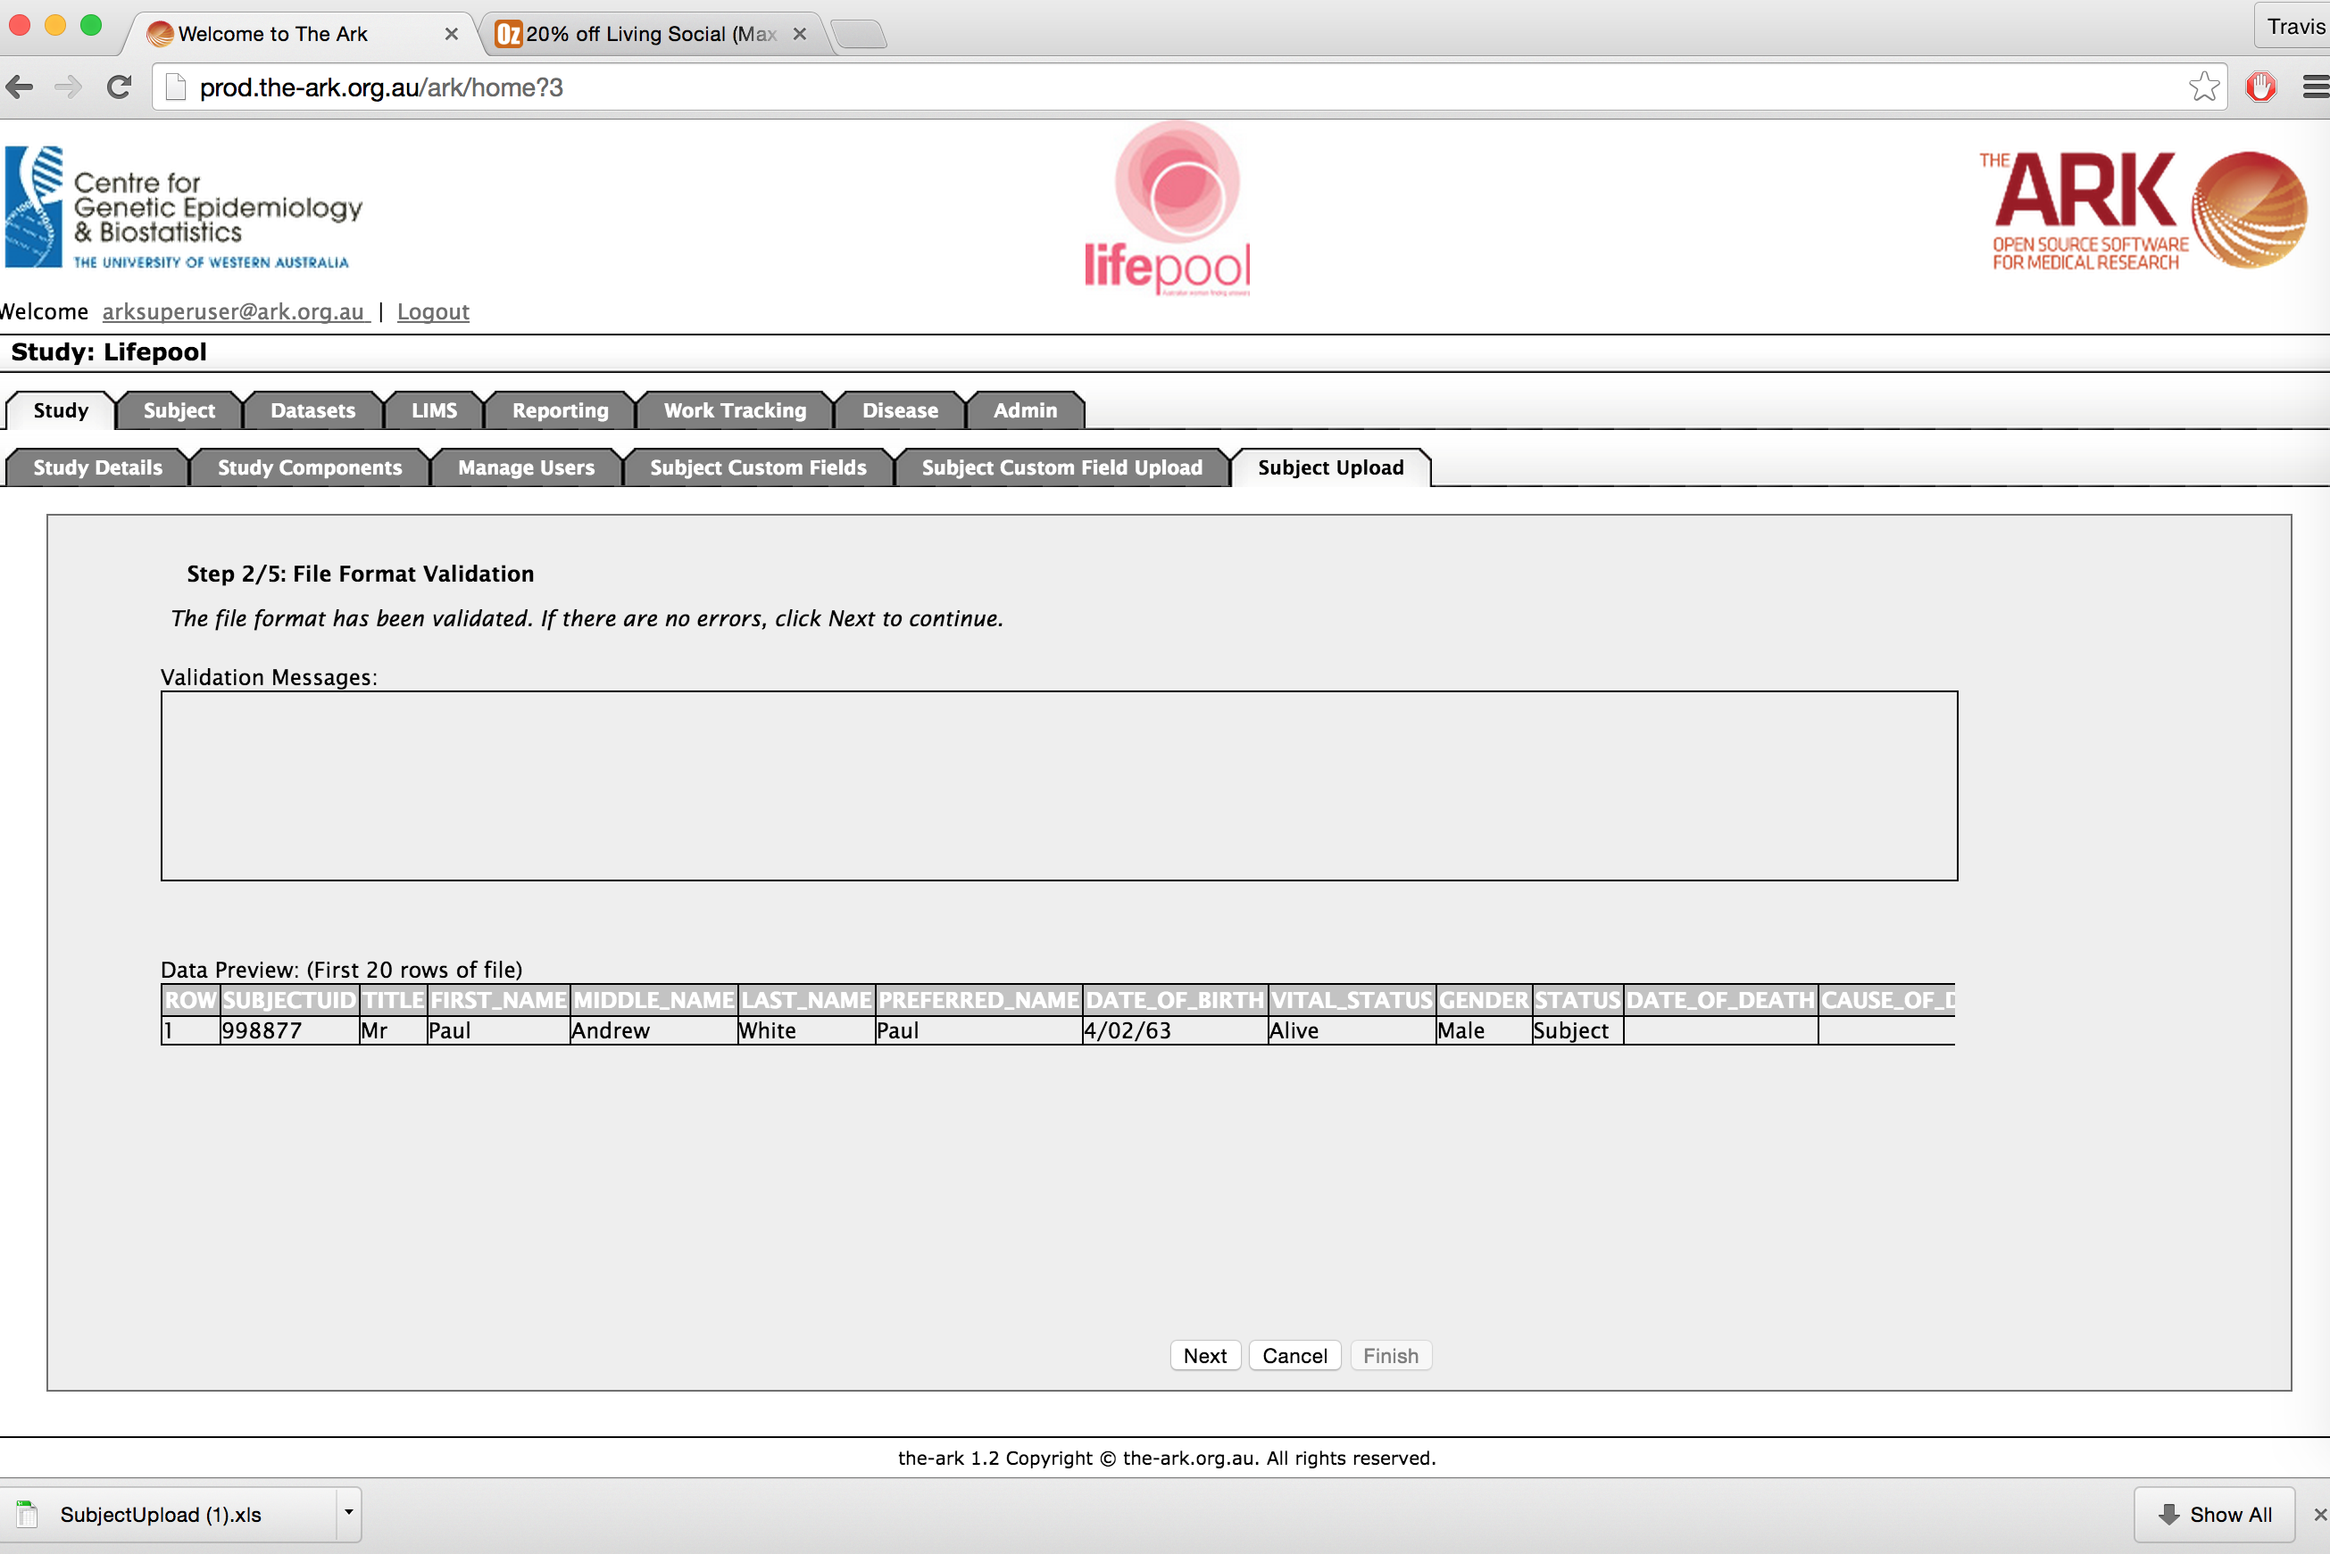

I see no validation messages at step 2, so I can assume everything is ok and click next at the bottom of the page (this step will validate all of your **data** Vs what is expected, so can take some time on very large files. Please be patient and don’t click back, as it is busy doing work and will let you know when it is complete).

We are now at step 3. This step shows if anything went wrong in step 2. The validation messages say I made an incorrect assumption of fields for SILENT, it should have a Boolean (true or false) type. So I have to fix the data and try again.

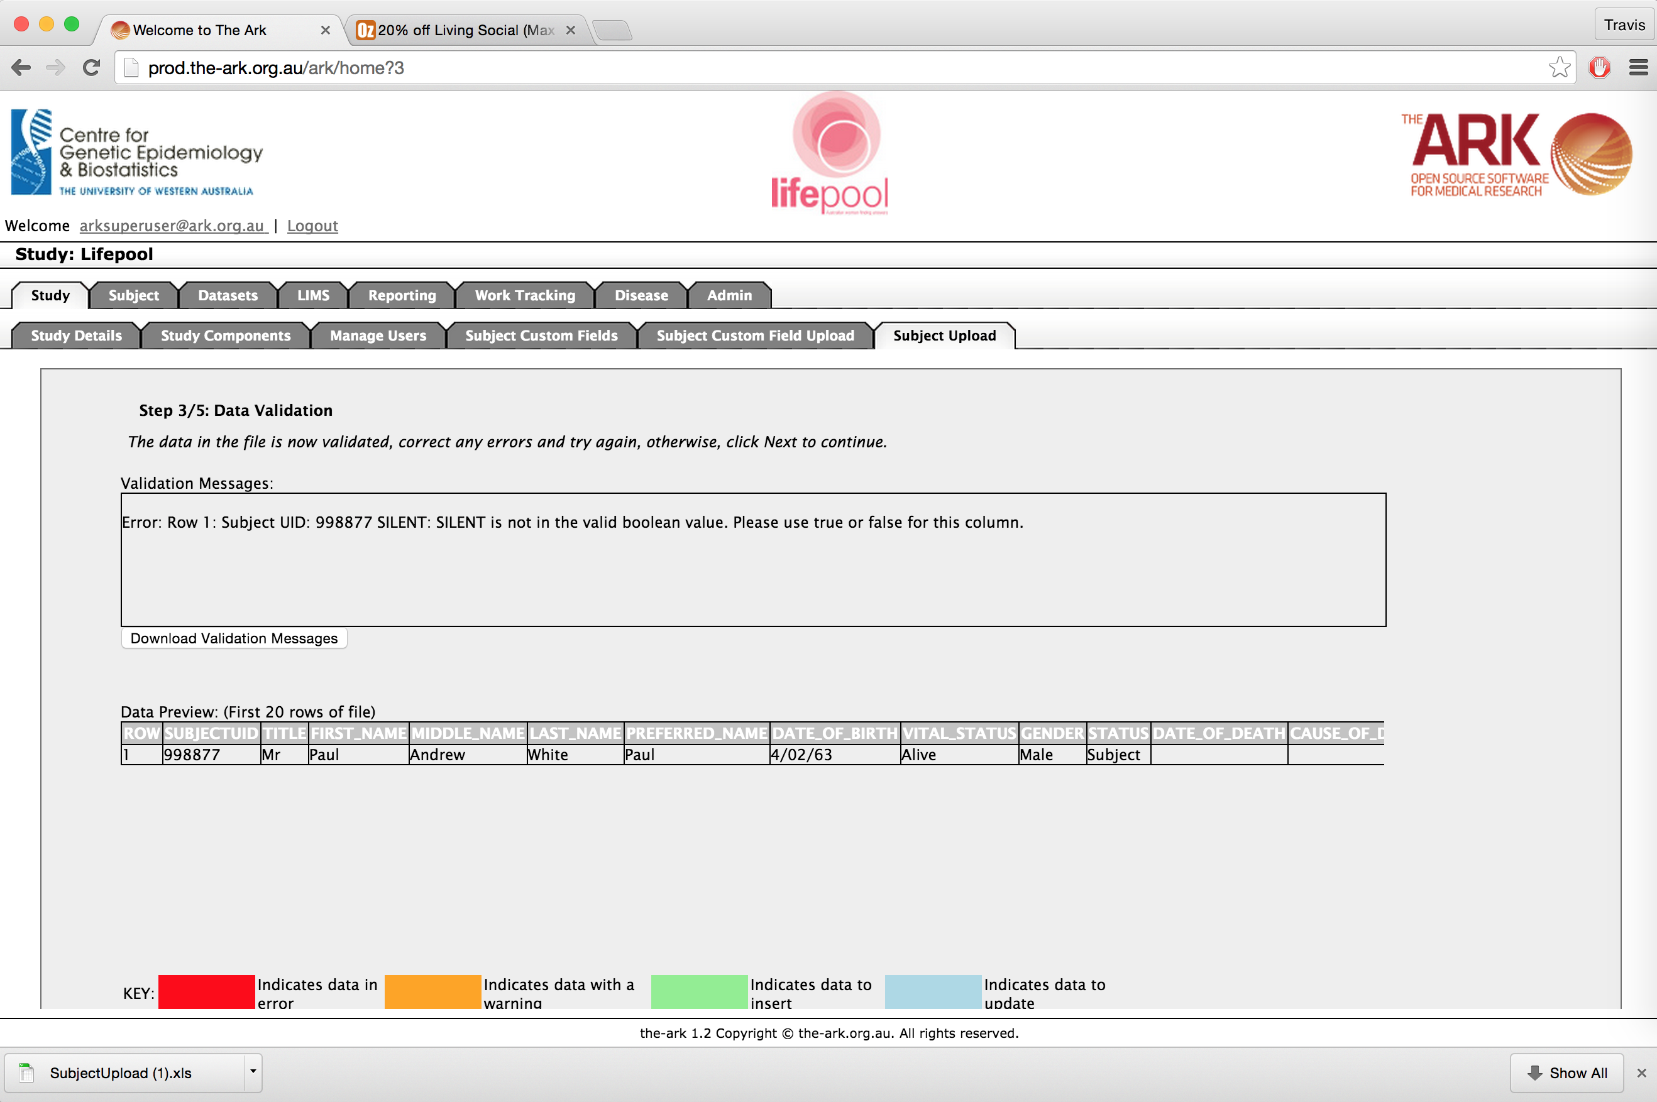

If we have corrected all of our data error we will now only one warning for the validation messages, letting us know that we are UPDATING an existing row. If you don’t see this, then something has gone wrong and you are likely to create a new person/row.

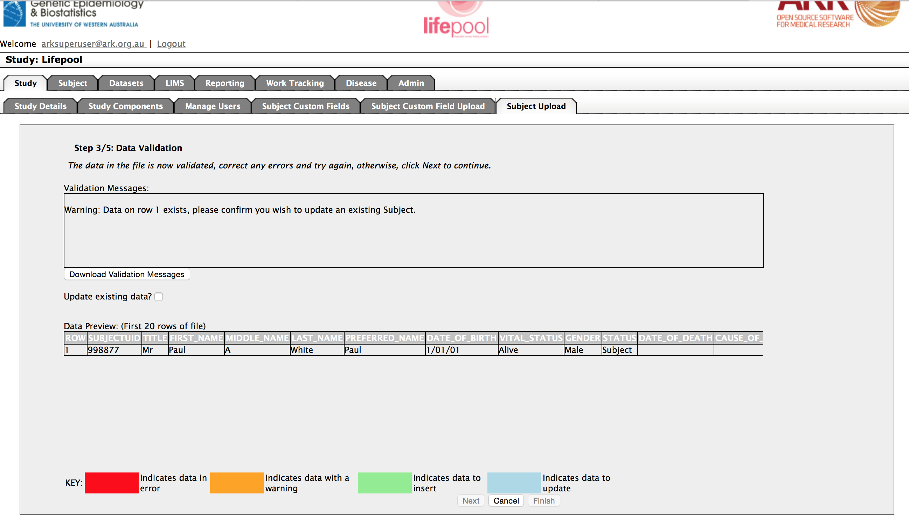

As you can see the “Next” button is not available. You need to acknowledge that you wish to update data by clicking the check box “Update existing data?”.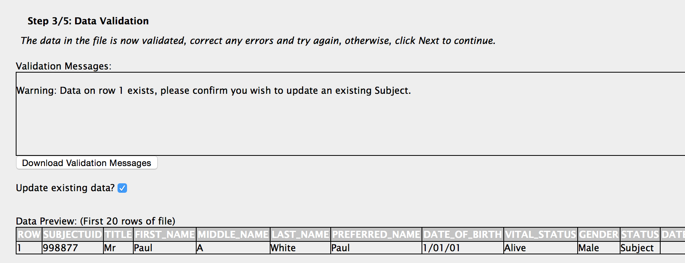

Once you have clicked that check box, you can now click next if you are happy with what you see.

You have now confirmed you are accepting the data, click next one more time and a BATCH process will begin.

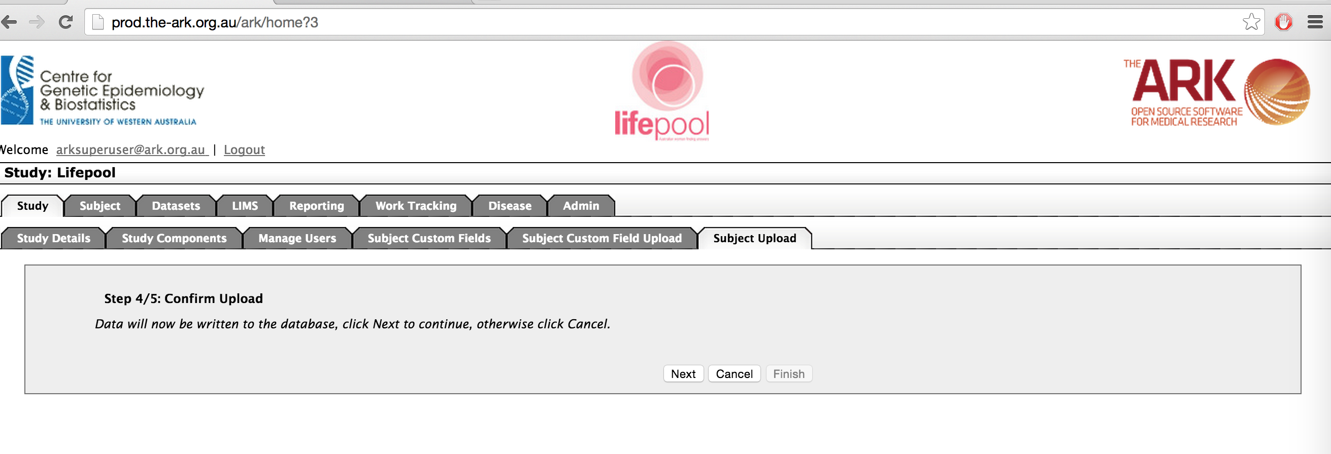

You now have completed the final step and can click finish whenever you want…

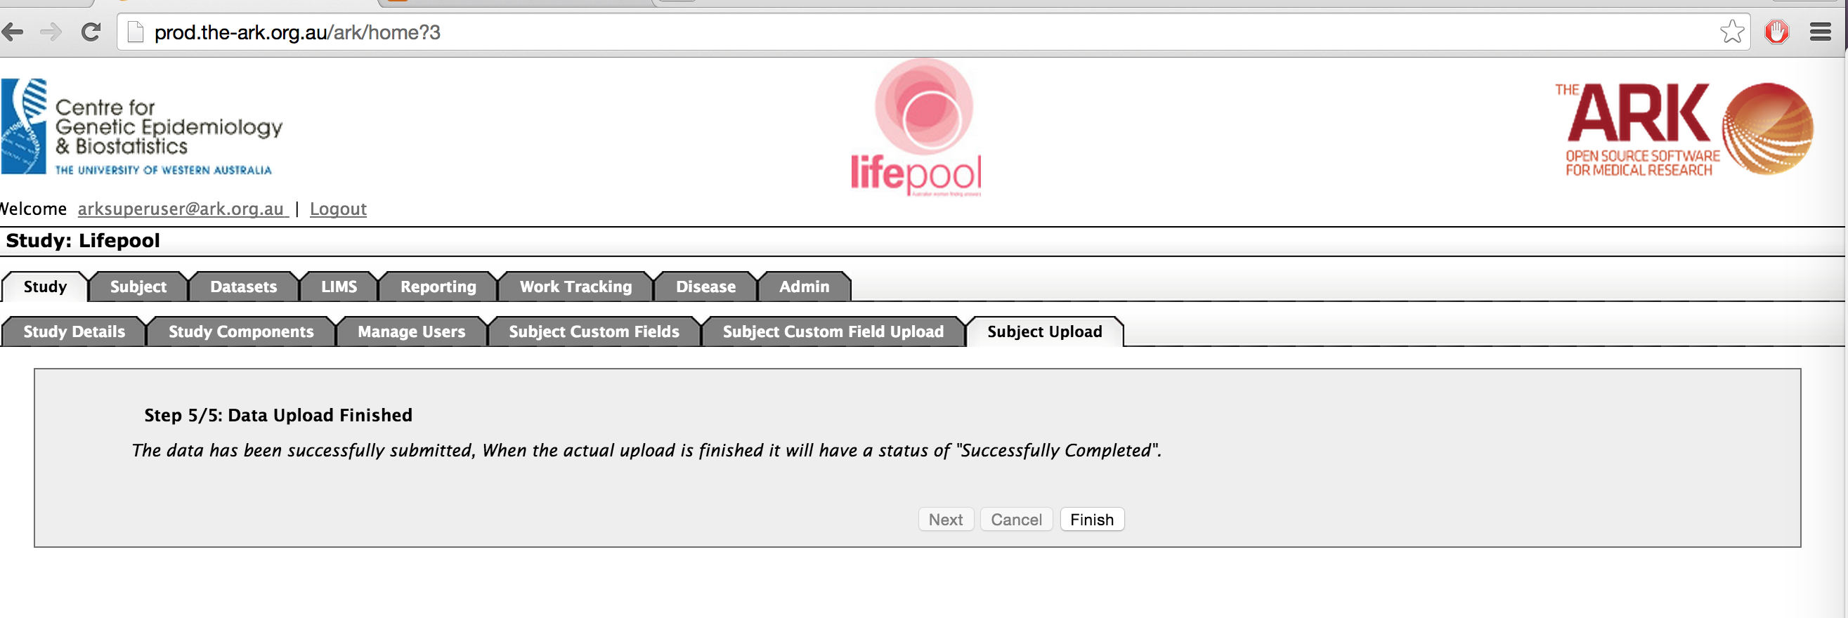

BUT must know that the data has been submitted BUT it has not been completed until the result list page says that your upload is in a “Successfully Completed” status.

This is what a successful upload will look like on the result list section. You can also see what you two previous unsuccessful attempts looked like (the first time we failed validation of the file (headers or file type/format), the second time we failed validation of the data.

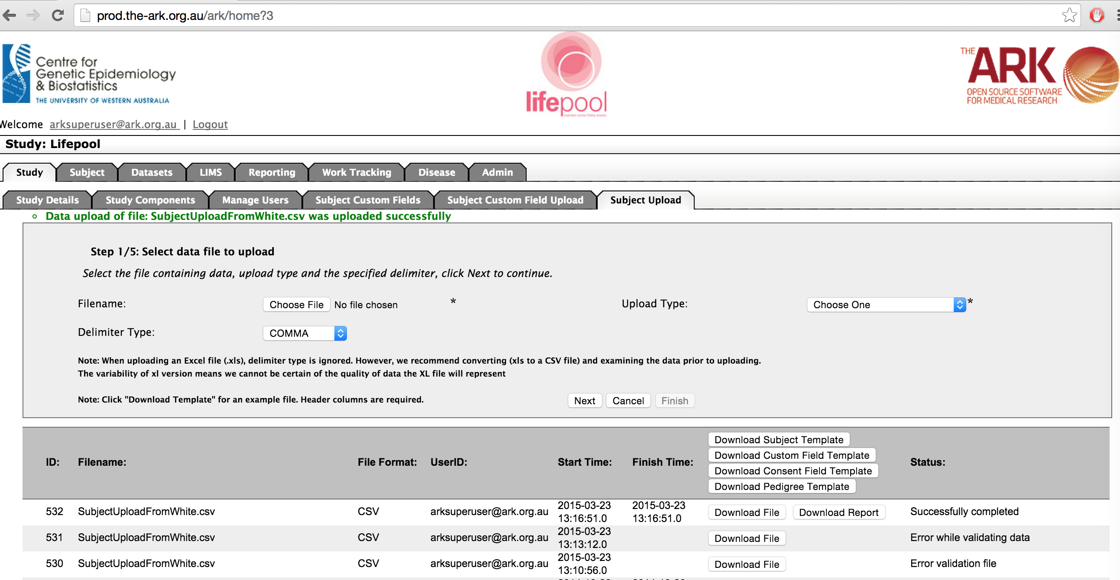

As you can see, in the results list for our successful upload, we have the options of Download File (this will down the original file you used) or Download Report which will give you a summary of what was uploaded, and any assumptions (or less serious errors) that were made upon successful rows. See an example below (not that subject is marked as updated Vs inserted);

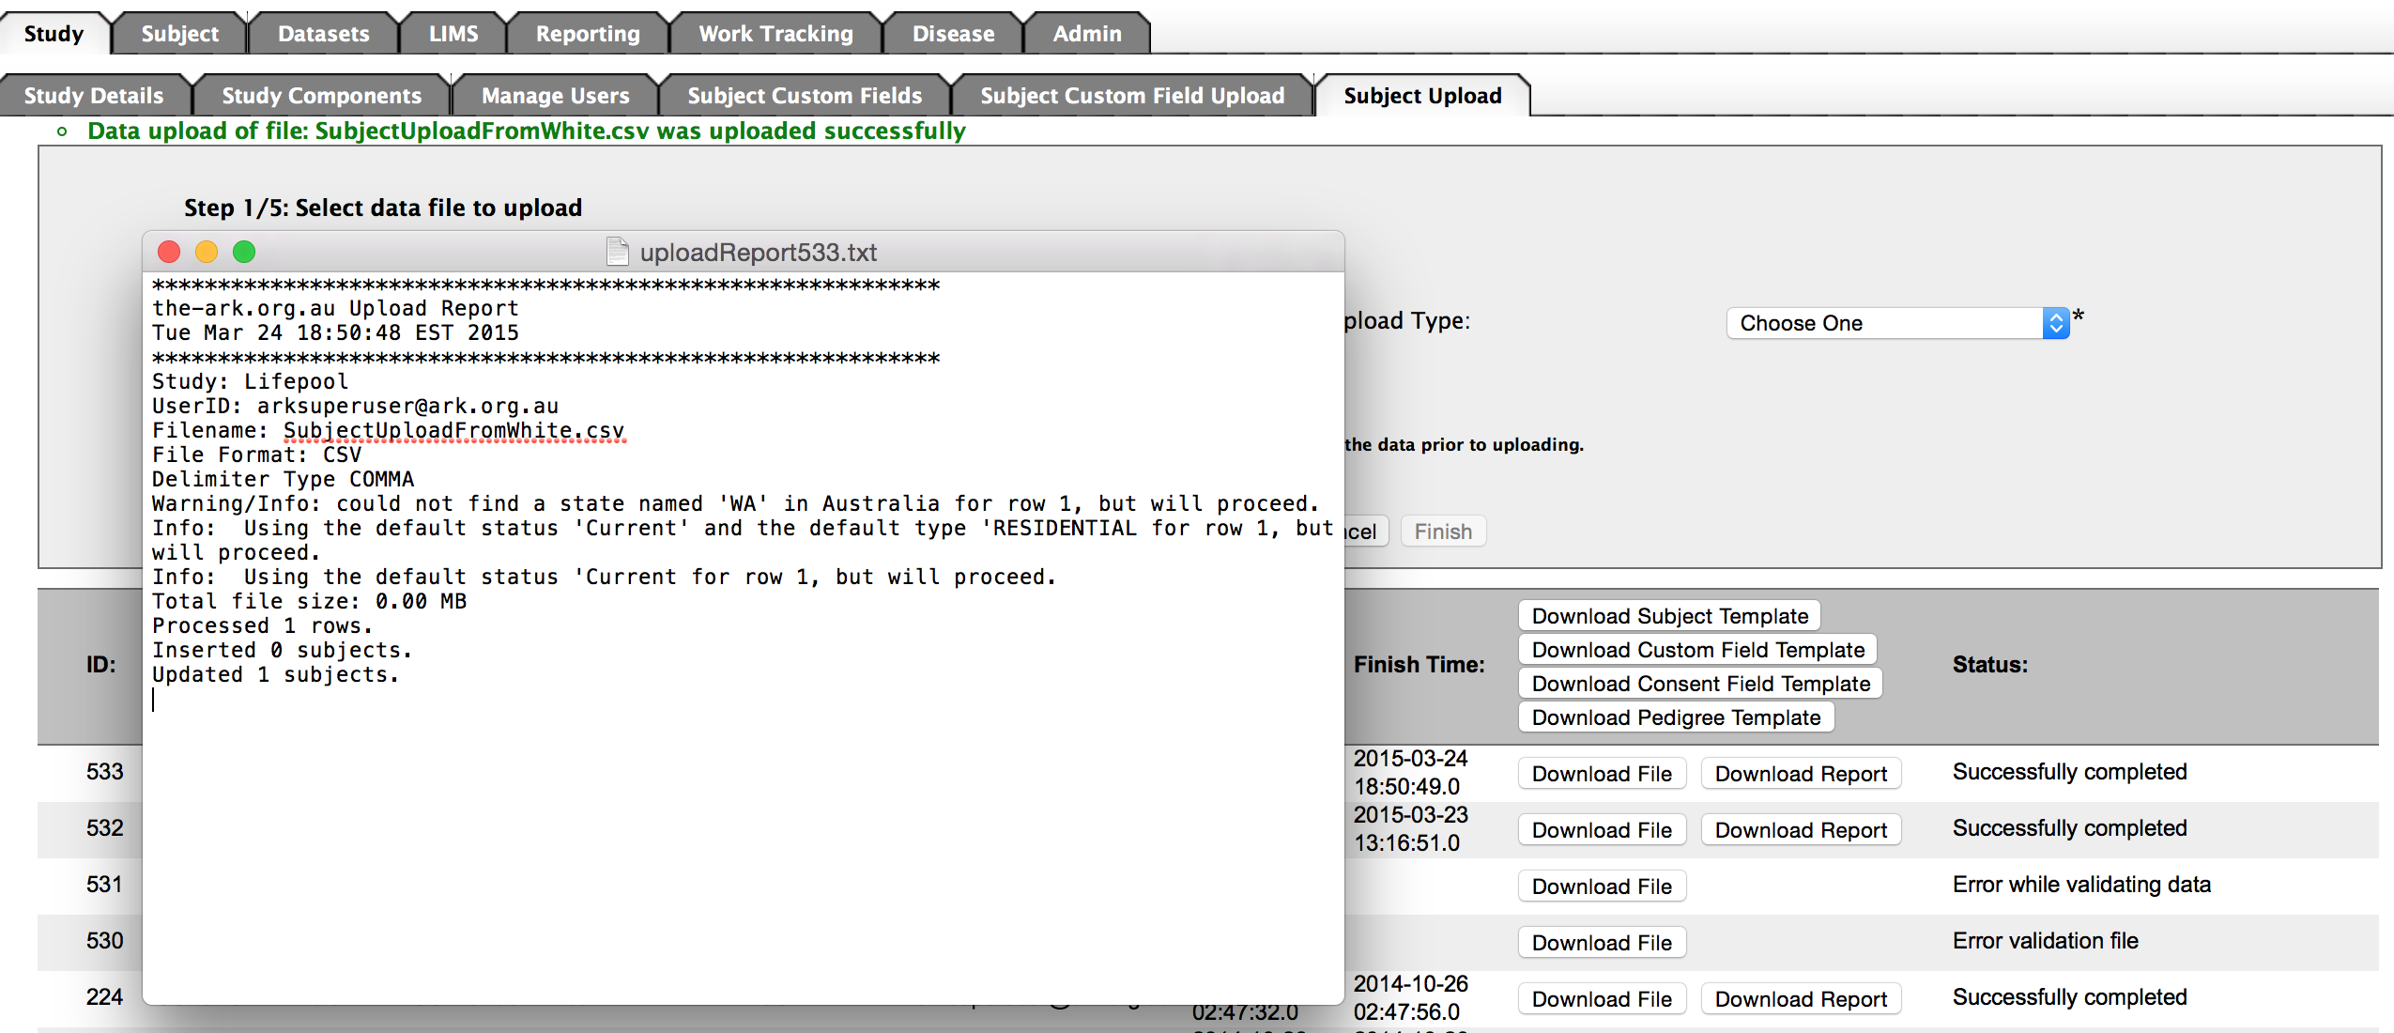

As always, we recommend you test what you just did to ensure the results were as you expected.

To do this, we click on the Subject Module Tab near the top of the page.

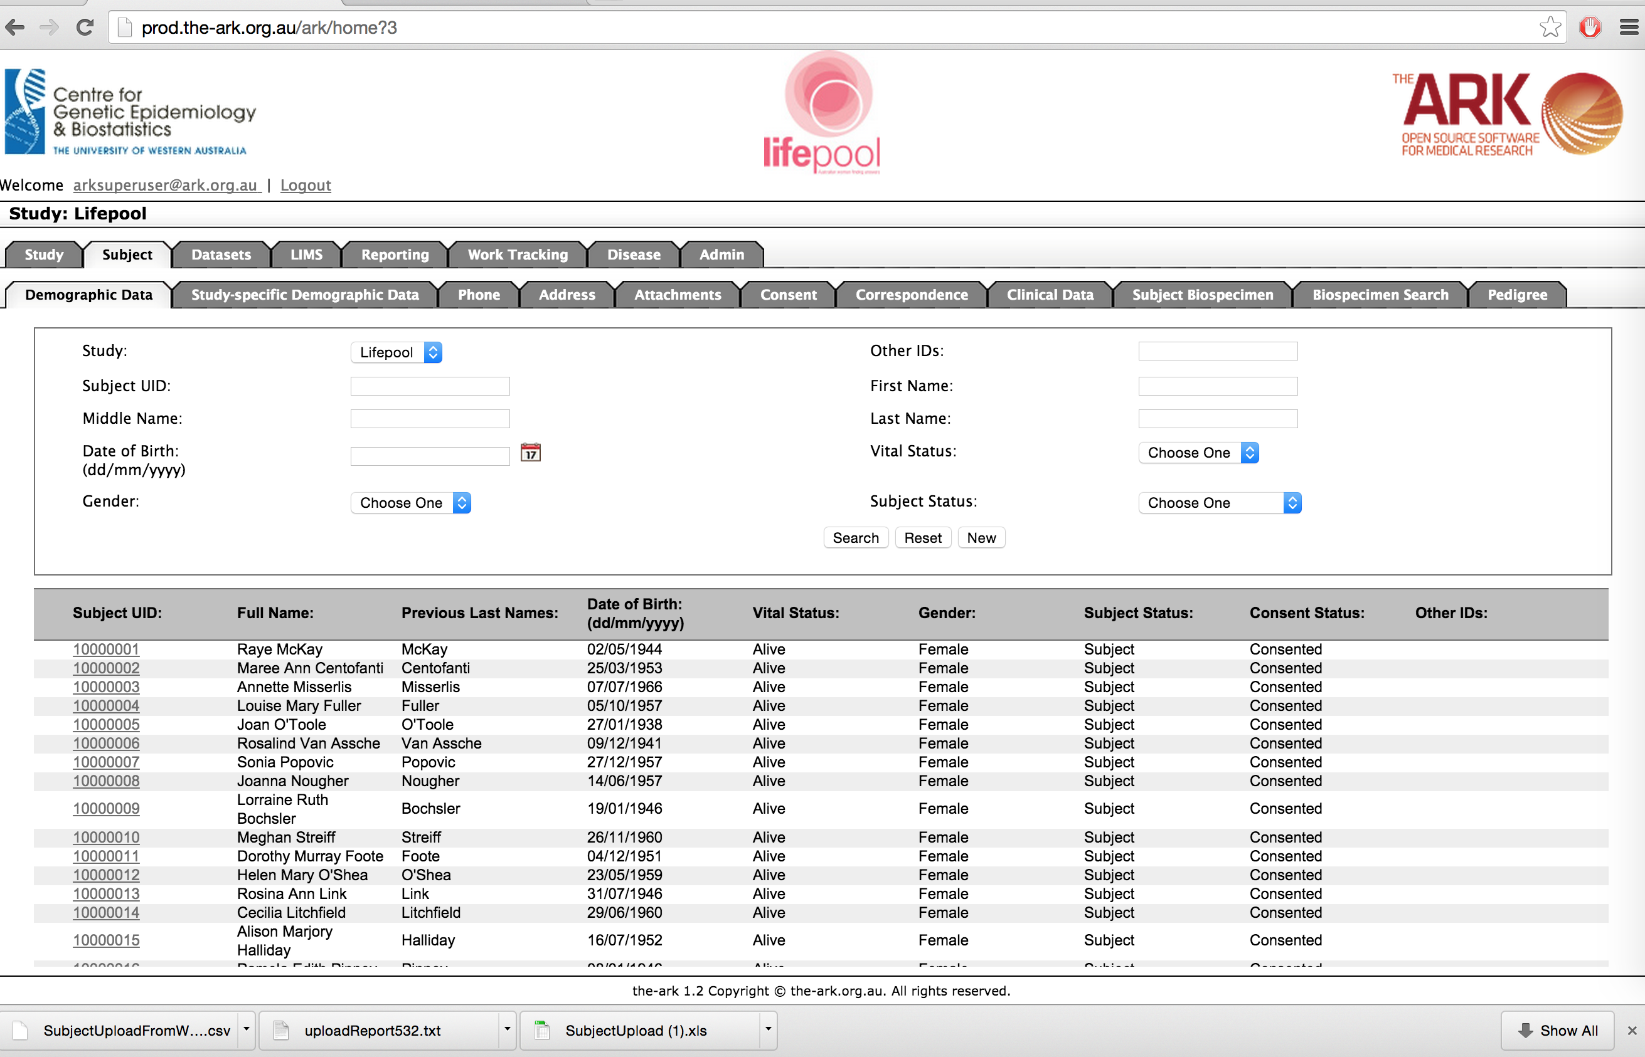

We can use a search term to find out subjects we wish to test;

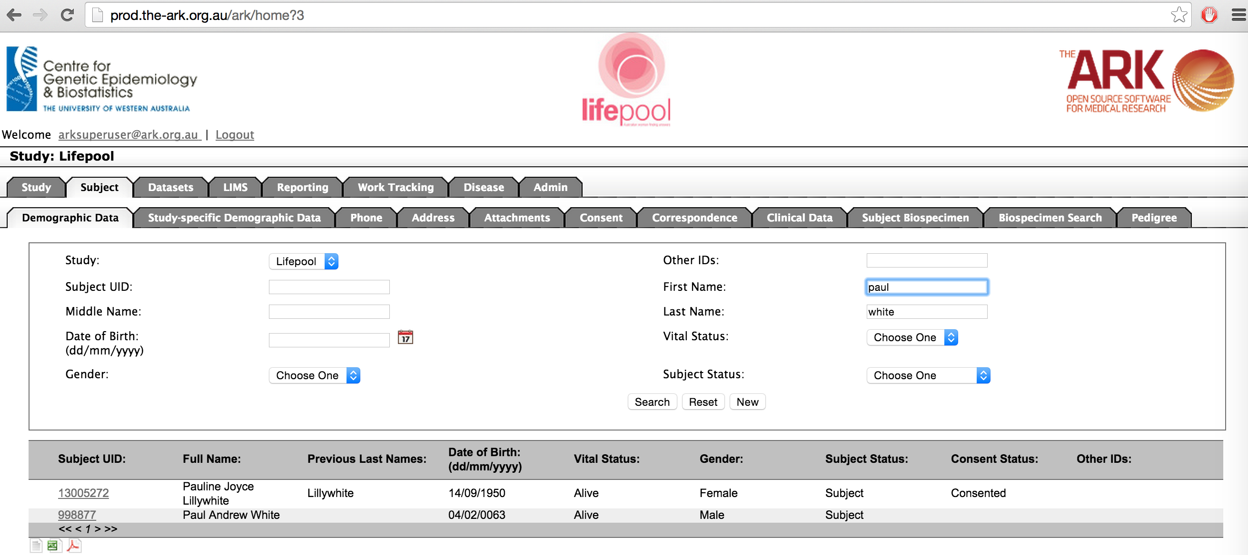

As you can see we found the name we just uploaded (Paul White). Click on his SubjectUID to test his uploaded & updated data has changed.

Hopefully all the data you expected is there. “Paul White” is now in context and you can go ahead and click on any information that you expect to see from him to make sure it was updated as expected.

